Annika Marie

**FIRST AMERICAN ARTISTS’ CONGRESS (14-16 February 1936)**

Word count: 459

The First American Artists’ Congress convened over three days in New York City, and marked the formal establishment of the American Artists’ Congress (1936-1942). The members of the organisation were brought together to act on behalf of artists, art, and artistic freedom. The Congress met its broad mandate by organising exhibitions, hosting symposia, publishing, fund-raising, protesting censorship and lobbying for artists’ rights. Although not overtly aligned with a political party, the Congress’s politics were in keeping with the Popular Front (1935-1939), the Communist Party’s strategy to forge connections with the non-revolutionary intelligentsia and liberal middle-class by emphasising their shared cultural values and stressing the necessity of a mutual alliance against fascism.

This first meeting of the Congress laid out the organisation’s main rallying points: (1) While the emergency relief programs set up in the Great Depression, such as the Works Progress Administration, were important recognitions by the federal government of the material distress of living artists as productive workers, these were only temporary, partial solutions. The Congress lobbied for permanent and much expanded government arts support. (2) Artists were threatened by political dictatorships that were intolerant of cultural difference, critical dissent, and the freedom of expression, as evident with Hitler in Germany and Mussolini in Italy. The Congress acted in solidarity with anti-fascist initiatives abroad and served as watchdog for encroachments of fascism at home, which could take the form of censorship and racism. (3) All efforts should be made to democratise culture and support the arts broadly. The Congress maintained that popular access to the arts was key in fostering a civilisation of peace, democracy and freedom.

The Congress’s position of stylistic and thematic inclusivity marks the main difference from its predecessor, the John Reed Club (1929-1935), an openly Soviet-oriented organization committed to proletarian/workers’ culture. As part of the new ‘Popular Front’ strategy to downplay divisive revolutionary rhetoric, the Congress did not prescribe artistic themes or subject matter and it embraced styles ranging from academic realism to formal abstraction.

The demise of the Congress follows the Popular Front’s decline. The Communist Party’s intolerance of independent voices and critical dissent revealed in the Moscow Trials of 1936 and 1938; the USSR’s negotiation with fascist Germany in the Nazi-Soviet Non-Aggression Pact of 1939; and the displays later that same year of its own militarism with its invasions of Poland and Finland eroded belief in the Popular Front platform. In the wake of these events, many Congress members resigned. The organization officially dissolved in 1942.

**References and Further Reading**

Baigell, M. and Williams, J. (eds.) (1986) *Artists Against War and Fascism: Papers of the First American Artists’ Congress*. New Brunswick, New Jersey: Rutgers University Press.

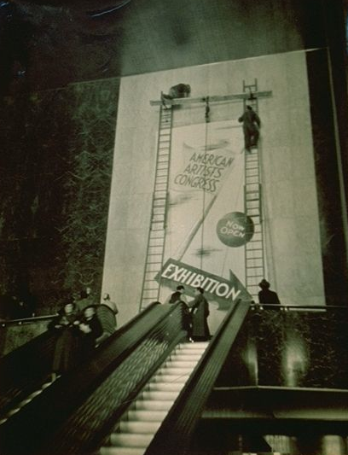

Men hanging banner for American Artists’ Congress exhibition, n.d. Black-and-white photograph, 9 5/8 x 7 1/2 inches, Mitchell Wolfson, Jr. Collection, Wolfsonian-Florida International University, Miami Breach, Florida.

[http://www.wolfsonian.org/explore/collections/men-hanging-banner-american-artists-congress-exhibition#](http://www.wolfsonian.org/explore/collections/men-hanging-banner-american-artists-congress-exhibition)

[NOTE: Copyright will probably come from the Wolfsonian]